DS.140 Integration Design Specification



HIS to Fusion Lot Amendment Integration

SCM_RICE_004

Author: Pranjul Garg

Creation Date: Apr 25, 2022

Last Updated: Jun 15, 2023

Version: 2.0

**Approvals:**

|  |  |
| --- | --- |
| <Approver 1> | <Rakesh Khanna / Naushad / Amit> |
| <Approver 2> | <Business Owner> |

# Document Control

## Change Record

| Date | Author | Version | Change Reference |
| --- | --- | --- | --- |
| 25-Apr-2022 | Pranjul Garg | 1.0 | No Previous Document |
| 09-Nov-2022 | Nidhi Siotia | 2.0 |  |
| 15-Jun-2023 | Nidhi Siotia | 2.1 | Reviewed |
|  |  |  |  |

2

## Reviewers

| Name | Position |
| --- | --- |
| FHL Business | Business User |
| FHL IT Group | Fortis IT Team |
|  |  |
|  |  |

Contents

1 Document Control ii

1.1 Change Record ii

1.2 Reviewers ii

2 Introduction 4

2.1.1 Scope for this Document 4

2.1.2 Intended Audience 4

3 Overview 5

3.1 Business Objectives 5

3.2 Major Features 5

3.3 Glossary 5

4 High-Level HIS to Fusion Integration flow 6

5 Technical Design Details 7

5.1 OIC Services 7

5.2 Oracle PaaS DBCS components 8

5.3 Technical flow 9

6 Error Reprocessing & SWEEP 14

7 HIS System 16

7.1 HIS Services 16

8 Data FIELD Mapping 17

8.1 File format 17

8.2 Frequency 17

9 Exception handling 18

9.1 Scenarios 18

10 Assumptions / Considerations 19

11 Open and Closed Issues 20

11.1 Open Issues 20

11.2 Closed Issues 20

# Introduction

### Scope for this Document

This analysis specification document is prepared to layout the HIS to Fusion Lot Amendment integration.

### Intended Audience

This document is intended for the following groups to provide the action items and consideration that are required to complete the implementation of the various Supply Chain and Finance related functionalities from Oracle Fusion.

#### Fortis Business Users

This document will be helpful for Fortis Business users to understand the technical design and process change with the new structure implemented in Oracle. The business user will validate this document after the verification of the requirement.

#### PwC Technical Team

The PwC technical team will use this document as a source technical design document to develop the technical solution to implement / deploy in Oracle Fusion.

#### Fortis IT Team

The Fortis IT Team must facilitate the PwC technical team for requisite details and other elements required from Business. The Fortis IT team is also responsible to arrange and provide required technical information wherever is required.

# Overview

Fortis Healthcare Limited (FHL) is a chain of hospitals, headquartered in India. Fortis started its health care operations from Mohali where first Fortis hospital was started. Later, the hospital chain purchased the healthcare branch of the Escorts group and increased its strength in various parts of the country. The Fortis health care also operates its hospital in Vasant Kunj, Faridabad, Gurgaon. The FMRI hospital at Gurgaon is the headquarter of Fortis healthcare with all the major facilities at the hospital.

This specification document is prepared to layout the design of HIS to Fusion Lot Amendment integration. Oracle PaaS DBCS has been used for validating the data before importing it to Oracle Fusion.

## Business Objectives

The following are the business objectives.

1. To have a secure, reliable, and scalable design flow from HIS to Oracle Fusion where the PaaS DBCS database acts as an intermediate layer to provide complete interface details.
2. To have a solution providing the monitoring capabilities.

## Major Features

The proposed solution will have the following features involved:

1. OIC integration as a REST Endpoint URL which is a starting point for HIS to invoke to interface a data file to Oracle fusion.
2. PLSQL packages & Shell scripts which exists in Oracle PaaS DBCS for data insertion into staging table, validation and preparing csv file in FBDI format to import the data in Oracle Fusion.

## Glossary

REST

Representational State Transfer.

OIC

Oracle Integration Cloud

# High-Level HIS to Fusion Integration flow

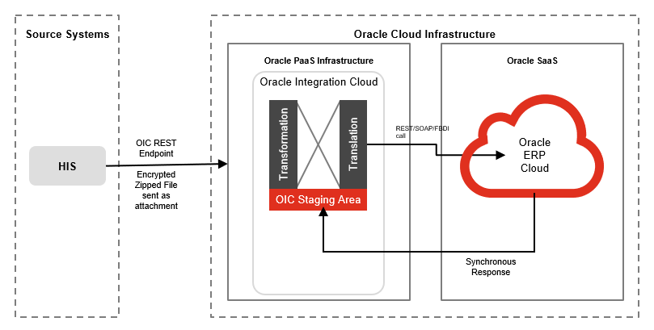

# Technical Design Details

This section describes the technical details of all the components involved in the design of HIS to Oracle Fusion Lot Amendment integration.

This interface has been built as per the details in the following document:



## OIC Services

An App driven orchestration has been designed in OIC to build a REST Endpoint URL, which accepts the file as a binary attachment, along with its checksum and file name.

|  |  |
| --- | --- |
| **OIC Integration Name** | Fortis HIS To Fusion Lot Amendment Integration |
| **OIC REST Endpoint URL** | https://oic-prod-nr5lr39yailj-bo.integration.ocp.oraclecloud.com:443/ic/api/integration/v1/flows/rest/FORTIS_HIS_FUSION_LOT_AMEND_INTG/1.0/callOIC/fusionInbound/ |
| **Method** | POST |
| **Request Media Type** | application/zip |
| **Request Headers** | fileName  SourceChecksum |
| **Response Media Type** | application/json |
| **Response sample** | { "FileID":"12345", "status" : "Source-target checksum matches,data is being processed" } |

Following OIC Integration is also an app driven orchestration which is being invoked from a shell script which takes the file from SFTP and processes it in Oracle fusion by invoking seeded ESS jobs: Load Interface File for Import and Manage Inventory Transactions.

|  |  |
| --- | --- |
| **OIC Integration Name** | Fortis Lot Amendment Process Integration |
| **OIC REST Endpoint URL** | https://oic-prod-nr5lr39yailj-bo.integration.ocp.oraclecloud.com:443/ic/api/integration/v1/flows/rest/FORTIS_LOT_AMEND_PROCESS_INTG/1.0/callOIC/processInvTransactions/ |
| **Method** | POST |
| **Request Media Type** | application/json |
| **Request sample** | { "FileId":"1234", "FileName" : "abc.zip" } |
| **Response Media Type** | application/json |
| **Response sample** | { "FlowId":"1234", "Status":"Processed successfully" } |

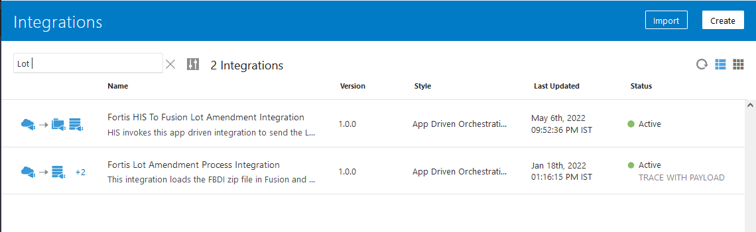

## Oracle PaaS DBCS components

This integration design uses the following components from Oracle PaaS DBCS:

|  |  |  |
| --- | --- | --- |
| **DB Component** | **Component name** | **Details** |
| **Tables** | XXFH_HIS_FILE_DETAILS_TBL | This is a common table for all the HIS related integrations (inbound & Outbound) to keep a track of all the files exchanged between HIS & Fusion. |
| XXFH_HIS_LOT_AMENDMENT_TXN_STG | This is an intermediate table which is used to load the data from flat file (csv) via sqlldr utility. Once the data from this table is passed to main interface table, the data is deleted from this table. |
| XXFH_HIS_LOT_AMENDMENT_TXN_TBL | This is the main interface table where the data is stored from XXFH_HIS_LOT_AMENDMENT_TXN_STG after doing type casting for DATE columns. |
| **Procedure** | XXFH_HIS_LOT_AMEND_WRAPPER_PRC | This is a wrapper PLSQL procedure which is being invoked from OIC integration to kick off data insertion, validation & Fusion import process. |
| **Package** | XXFH_HIS_LOT_AMENDMENT_PKG | This package is being used to validate the data and update the transactional status back to the main interface table once the data is imported to Fusion. |
| **Shell scripts** | XXFH_HIS_DATA_LOAD_SCRIPT.sh | This is a common shell script to load the data from flat file (csv) to the first staging table. |
| XXFH_LOT_AMENDMENT_FBDI_SCRIPT.sh | This shell script is used to fetch the validated data of the current batch in the form of Oracle Fusion FBDI template and invoke the OIC integration to process the data in Oracle Fusion. |

## Technical flow

Following is the complete technical flow for this integration design:

HIS invokes 1st OIC REST Endpoint URL ([Fortis HIS To Fusion Lot Amendment Integration](https://oic-prod-nr5lr39yailj-bo.integration.ocp.oraclecloud.com/ic/home/?root=integrations&oj_Router=1N4IgTg9hAuIFygGYEsA20CmYDKHrWQDsBzAZ3lCM2LAEMCJDyERSIxoB5ABwaYoC+AGhAp0WHn2YBtALojSGWmADGACwCShbgFdYLRcvUAhAJ4A1Wqh0Z4IADIwABCGEhaKvncOq1AWjFMMD82DhARNSUAEyxsdiDJZEZmYAE0tKA)) using basic authentication by providing an encrypted zip file. HIS invokes this REST endpoint URL to interface the data from HIS to Fusion periodically.

Once the 1st OIC REST endpoint URL is invoked, it does the following operations:

* Check if the given file has been received before. If yes, then stop the integration flow and return the message as response to HIS as “This file has already been received before, please check.”.
* Insert an entry into a common table (XXFH_HIS_FILE_DETAILS_TBL) for HIS related integrations for the given file in Oracle PaaS DBCS with FILE_STATUS as “Received”.
* Calculate target checksum in OIC and matches it with the source checksum which HIS has sent as an input while invoking this integration. If checksum doesn’t match, then stop the integration and return the message as response to HIS as "Source-target checksum do not match, please resend the file with correct checksum".
* If both checksum matches, decrypt the file using FTP adapter in OIC (the private key pair of PGP key has been configured within OIC FTP connection), unzip it and then place the csv file at DBCS FTP server path: /d01/inbound/HIS/LotAmendment/
* Invoke the PLSQL wrapper procedure: XXFH_HIS_LOT_AMEND_WRAPPER_PRC, which invokes the shell script to load data from csv file to table: XXFH_HIS_LOT_AMENDMENT_TXN_STG and then invoke procedure: XXFH_HIS_LOT_AMENDMENT_PKG.XXFH_VALIDATE_LOT_DATA_PRC to validate the data. This validation procedure is executed as a DBMS scheduler job in the database so that OIC doesn’t have to wait for its completion.
* The 1st OIC integration completes here and returns a response back to HIS as “Source-target checksum matches,data is being processed”.

1. PLSQL procedure: XXFH_HIS_LOT_AMENDMENT_PKG.XXFH_VALIDATE_LOT_DATA_PRC validates the data of the current batch one by one and mark them either as ‘V’ -> Validated or ‘E’ -> Error in table: XXFH_HIS_LOT_AMENDMENT_TXN_TBL.
2. Once validation completes for all the records, it checks if there are successful validated records for the current batch. If yes, then it invokes a shell script: XXFH_LOT_AMENDMENT_FBDI_SCRIPT.sh.
   1. This shell scripts spool all the validated records of the current batch as per the Oracle standard FBDI format and creates a zip file which contains 2 csv files: INV_TRANSACTIONS_INTERFACE & INV_TRANSACTION_LOTS_INTERFACE.
   2. Thereafter, this shell script only invokes the 2nd OIC integration (Fortis Lot Amendment Process Integration) which basically invokes “Load Interface File for Import” & then “Manage Inventory Transactions” ESS jobs in Oracle Fusion.
   3. Once these ESS jobs completes, OIC integration invokes procedure: XXFH_HIS_LOT_AMENDMENT_PKG.XXFH_UPDATE_STATUS_PRC to update the status for each & every transaction in table: XXFH_HIS_LOT_AMENDMENT_TXN_TBL.
3. The accounting string derivation logic for each & every transaction is as follows: It is applicable only for transaction type: “Lot Update (I)” & “Lot Update (R)”

* SEGMENT1 is derived as the hospital code for the given transaction.
* SEGMENT5 is derived from lookup: XXFH_HIS_INV_CONSUM_ACCT_LKP based on Lot amendment transaction type.
* SEGMENT2 to SEGMENT10 (except SEGMENT5) are used as default values.

1. For records where transaction type is received as “LOT_EXPIRY_MRP_CHANGE”, such records are processed by invoking Oracle seeded REST API for updating the lot.

* For this transaction type, either the Lot expiration date or the Batch MRP (INV_LOT_NUMBERS.ATTRIBUTE2) is to be changed.
* REST API “fscmRestApi/resources/latest/inventoryItemLots/” is used to update these 2 fields for a given Lot in fusion.
* For this transaction type, if XXFH_HIS_LOT_AMENDMENT_TXN_TBL.NEW_MRP is not null, then it means that MRP needs to be updated.
* Similarly, if XXFH_HIS_LOT_AMENDMENT_TXN_TBL.LOT_EXPIRATION_DATE is not null for this transaction type, it means that the expiration date needs to be updated.

1. The Oracle team has to send a single response/acknowledgement against 2 transactions received from HIS of a single pair for “Lot Update (I)” & “Lot Update (R)”. The response/acknowledgement file from Oracle fusion to HIS should not be blank. Oracle team should send the actual processed quantity in Fusion to HIS in its response file.

* Oracle team should send the actual processed quantity in Fusion to HIS in its response file.
* If the complete quantity (received from HIS) is processed in Fusion, then the ERROR_MSG column in the response file from fusion will be blank.
* If the partial quantity (received from HIS) is processed in Fusion, then the ERROR_MSG column in the response file from Fusion will have a message of not having sufficient onhand stock. QUANTITY_PROCESSED field in the response file will have the partial quantity which is actually processed in Oracle fusion.
* If the complete quantity fails in Oracle fusion, then the QUANTITY_PROCESSED field in the response file will have the quantity as 0 and ERROR_MSG field will have the error message.

1. Oracle is not expected to send any response back to HIS (be it success or failure) for “LOT_EXPIRY_MRP_CHANGE”

**Validations:**

PLSQL procedure XXFH_HIS_LOT_AMENDMENT_PKG.XXFH_VALIDATE_LOT_DATA_PRC executes the following validations:

* HOSPITAL_CODE cannot be null.
* HOSPITAL_CODE received from HIS should be a valid one which is defined in Fusion application.
* TRANSACTION_TYPE cannot be null.
* TRANSACTION_TYPE (except “LOT_EXPIRY_MRP_CHANGE”) must be defined in Fusion application as a valid Inventory transaction type.
* Same HIS_STAGING_ID cannot be received & processed again.
* SUBINVENTORY_CODE cannot be NULL for Lot Update transaction type.
* ITEM_CODE & LOT_NUMBER cannot be null.
* LOT_QUANTITY must be a positive value (greater than 0).
* UOM cannot be null.
* For transaction type: LOT_EXPIRY_MRP_CHANGE, both NEW_LOT_EXPIRY_DATE & NEW_MRP cannot be null.
* TRANSACTION_DATE cannot be null.
* GL Period in Fusion for the given TRANSACTION_DATE must be opened in Fusion application.

Following are the few important SFTP server paths which are being used for this integration design:

|  |  |
| --- | --- |
| /d01/inbound/HIS/LotAmendment/Archive/ | Once the file is processed via 1st OIC integration, the encrypted zip file is archived in this path. |
| /d01/inbound/HIS/Errors/ | The sqlldr utility related log & bad files are placed here. |
| /d01/inbound/HIS/Archive/ | The data csv file is archived here. |

**Server details:**

|  |  |  |  |  |
| --- | --- | --- | --- | --- |
| **Server** | **Host name** | **Port** | **Service Name** | **Username** |
| Oracle DBCS SFTP | 140.238.225.129 | 22 | NA | oracle |
| Oracle PaaS DB | 140.238.225.129 | 1521 | PRODPDB1.fhpubsn.fhvcn.oraclevcn.com | XXFH & XXFH_RO |

**Oracle PaaS Table design:**

* + - 1. Table: XXFH_HIS_FILE_DETAILS_TBL

|  |  |  |  |  |
| --- | --- | --- | --- | --- |
| **S.No.** | **Table Column** | **Data Type** | **Length** | **Remarks** |
| 1 | FILE_ID | NUMBER | 22 | For Fusion Inbound integrations, this is OIC_FLOW_ID of the OIC Integration run. |
| 2 | FILE_NAME | VARCHAR2 | 240 | File name of Fusion inbound or Outbound integration |
| 3 | INTG_TYPE | VARCHAR2 | 30 | Inbound/Outbound |
| 4 | MODULE_NAME | VARCHAR2 | 30 | Used for Fusion Outbound interfaces only, HIS specific field to bifurcate the file as per various Fusion Outbound interfaces |
| 5 | SRC_CHECKSUM | VARCHAR2 | 240 | Checksum (MD5) calculated of the final file at the source end |
| 6 | FILE_STATUS | VARCHAR2 | 30 |  |
| 7 | ERROR_MSG | VARCHAR2 | 4000 |  |
| 8 | ADDITIONAL_INFO | VARCHAR2 | 4000 | Contains HIS REST API response for Fusion Outbound interfaces. Contains Fusion specific ESS job ids for Fusion Inbound interfaces. |
| 9 | OIC_FLOW_ID | NUMBER | 22 |  |
| 10 | SCHEDULER_JOB_NAME | VARCHAR2 | 100 |  |
| 11 | PROCESSING_START_DATE | DATE | 7 |  |
| 12 | PROCESSING_END_DATE | DATE | 7 |  |
| 13 | CREATION_DATE | DATE | 7 | WHO columns |
| 14 | CREATED_BY | VARCHAR2 | 30 |
| 15 | LAST_UPDATE_DATE | DATE | 7 |
| 16 | LAST_UPDATED_BY | VARCHAR2 | 30 |

* + - 1. Table: XXFH_HIS_LOT_AMENDMENT_TXN_TBL

|  |  |  |  |  |
| --- | --- | --- | --- | --- |
| **S.No.** | **Table Column** | **Data Type** | **Length** | **Remarks** |
| 1 | FILE_NAME | VARCHAR2 | 50 |  |
| 2 | HIS_TRANSACTION_ID | NUMBER | 22 | Field which joins Lot Update transaction |
| 3 | HIS_STAGING_ID | NUMBER | 22 |  |
| 4 | HOSPITAL_CODE | VARCHAR2 | 20 |  |
| 5 | TRANSACTION_TYPE | VARCHAR2 | 100 |  |
| 6 | TRANSACTION_DATE | DATE | 7 |  |
| 7 | ITEM_CODE | VARCHAR2 | 300 |  |
| 8 | LOT_NUMBER | VARCHAR2 | 80 |  |
| 9 | LOT_QUANTITY | NUMBER | 22 |  |
| 10 | LOT_EXPIRATION_DATE | DATE | 7 |  |
| 11 | UOM | VARCHAR2 | 20 |  |
| 12 | SUBINVENTORY_CODE | VARCHAR2 | 20 |  |
| 13 | LOCATOR | VARCHAR2 | 50 |  |
| 14 | ORGANIZATION_CODE | VARCHAR2 | 20 |  |
| 15 | ORGANIZATION_NAME | VARCHAR2 | 240 |  |
| 16 | NEW_LOT_EXPIRY_DATE | DATE | 7 |  |
| 17 | NEW_MRP | NUMBER | 22 |  |
| 18 | ORG_TYPE | VARCHAR2 | 30 | Possible values are "HIS, OP PHARMACY" |
| 19 | CONCATENATED_SEGMENTS | VARCHAR2 | 240 |  |
| 20 | OIC_FLOW_ID | NUMBER | 22 |  |
| 21 | FUSION_LOAD_REQ_ID | NUMBER | 22 |  |
| 22 | FUSION_IMPORT_REQ_ID | NUMBER | 22 |  |
| 23 | INV_TXN_ID | NUMBER | 22 |  |
| 24 | EXECUTION_SEQ | NUMBER | 22 |  |
| 25 | PROCESS_FLAG | VARCHAR2 | 1 |  |
| 26 | ERROR_MSG | VARCHAR2 | 4000 |  |
| 27 | ATTRIBUTE1 | VARCHAR2 | 240 |  |
| 28 | ATTRIBUTE2 | VARCHAR2 | 240 |  |
| 29 | ATTRIBUTE3 | VARCHAR2 | 240 |  |
| 30 | ATTRIBUTE4 | VARCHAR2 | 240 |  |
| 31 | ATTRIBUTE5 | VARCHAR2 | 240 |  |
| 32 | ACTUAL_PROCESSED_QTY | NUMBER | 22 | Added by Pranjul |
| 33 | RESPONSE_SEND_FLAG | VARCHAR2 | 30 | Added by Pranjul |
| 34 | CREATION_DATE | DATE | 7 | WHO Columns |
| 35 | CREATED_BY | VARCHAR2 | 30 |
| 36 | LAST_UPDATE_DATE | DATE | 7 |
| 37 | LAST_UPDATED_BY | VARCHAR2 | 30 |



# Error Reprocessing & SWEEP

To reprocess the error records, following steps can be executed on an adhoc basis:

* Execute the following UPDATE query to update process_flag, oic_flow_id & error_message columns for the error records:

update xxfh_his_lot_amendment_txn_tbl

set process_flag = 'N', error_message = null, oic_flow_id = <can be put a unique id YYYYMMDDHHMMSS>,

last_update_date = sysdate

where process_flag = 'E' and error_message is not null;

* Invoke the following DBMS scheduler job for the given oic_flow_id (updated in the above step):

begin

sys.DBMS_SCHEDULER.create_job (

job_name => 'HisLotAmendment_1_' || <oic_flow_id updated as per 1st step>,

job_type => 'PLSQL_BLOCK',

job_action => 'BEGIN

XXFH_HIS_LOT_AMENDMENT_PKG.XXFH_VALIDATE_LOT_DATA_PRC ('

|| <oic_flow_id updated as per 1st step>

|| ','

|| ''''

|| 'a'

|| ''''

|| ','

|| ''''

|| 'a'

|| ''''

|| ','

|| ''''

|| 'a'

|| ''''

|| ','

|| ''''

|| 'a'

|| ''''

|| ','

|| ''''

|| 'a' || '''' || ',' || '''' || 'ORACLE'

|| ''''

|| ');

END;',

enabled => TRUE,

auto_drop => TRUE,

comments => 'To invoke Lot amendment code');

end;

/

In Order to sweep the previous month’s error records in the current month,

* Store the original transaction_date in Attribute1 field

update xxfh_his_lot_amendment_txn_tbl

set attribute1 = transaction_date, last_update_date = sysdate

where process_flag = 'E' and error_message is not null and attribute1 is null;

* Update the current month’s 1st day as transaction date for all the error records:

update xxfh_his_lot_amendment_txn_tbl

set transaction_date = to_date('01-APR-2022 06:00:00' , 'DD-MON-YYYY HH24:MI:SS'),

last_update_date = sysdate

where process_flag = 'E' and error_message is not null;

# HIS System

HIS system acts the first layer of transactional system for Fortis business.

## HIS Services

HIS REST based web-services are used to send the response file to share the transactional status:

|  |  |
| --- | --- |
| **HIS Username** | HIS_Integ_USER_PROD |
| **HIS Encryption Key** | FAC70AF7 |

|  |  |  |  |
| --- | --- | --- | --- |
| **SI No** | **Service Details** | **Parameters** | **Description** |
| 1 | https://ihisapi.fortishealthcare.com/api/ValidateUser |  | To validate HIS user and get the authentication token |
| 2 | https://ihisapi.fortishealthcare.com/api/FusionPaaS/UploadFile |  |  |
| 3 | https://ihisapi.fortishealthcare.com/api/FusionPaaS/errorfiles |  |  |

# Data FIELD Mapping

Integration data field mapping from Fusion to HIS format.

## File format

HIS sends the data for Inventory consumption interface as per the following file format:



## Frequency

HIS invokes OIC REST Endpoint URL every half an hour to interface the data file to Oracle fusion.

# Exception handling

There can be various scenarios for an error to occur. This section defines those error scenarios and the exception handling has been done to notify and act accordingly.

## Scenarios

In a tabular format give list of scenarios and exception handling

* When HIS sends a data file by invoking OIC REST Endpoint URL to Oracle fusion, if any of the step or node fails within this OIC integration, Global Fault section is configured within this OIC integration to update the error to XXFH_HIS_FILE_DETAILS_TBL. Also, it sends an OIC error notification with relevant details.
* Following is the sample error notification. The email id has been stored in OIC Lookup: Fortis_HIS_Integration_Details_Lookup against the given OIC integration name.

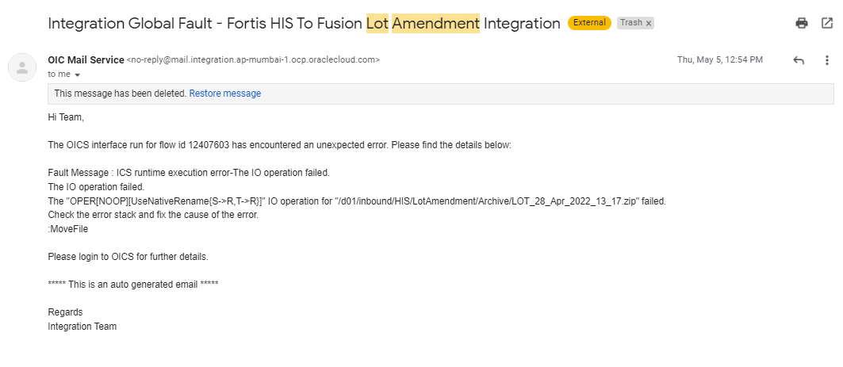

* If anything fails in the database PLSQL procedure, WHEN OTHERS exception has been handled everywhere which updates the error detail in XXFH_HIS_FILE_DETAILS_TBL for the given file name.
* In case, there is a record which has double inverted comma within that field value, then it will fail in sqlldr utility while loading the data from flat file to the table. Such errors cannot be notified as well. To check for such errors, the bad files under ‘/d01/inbound/HIS/Errors/” folder of DBCS SFTP can be checked periodically with partial file name as “*Lot*.bad”

# Assumptions / Considerations

The Proposed Solution will have the following technical considerations.

In the future, if any product bug arises in functionality then this process needs to be revisited after the bug is fixed.

# Open and Closed Issues

## Open Issues

| ID | Issue | Resolution | Responsibility | Target Date | Impact Date |
| --- | --- | --- | --- | --- | --- |
|  |  |  |  |  |  |
|  |  |  |  |  |  |
|  |  |  |  |  |  |
|  |  |  |  |  |  |

## Closed Issues

| ID | Issue | Resolution | Responsibility | Target Date | Impact Date |
| --- | --- | --- | --- | --- | --- |
|  |  |  |  |  |  |
|  |  |  |  |  |  |
|  |  |  |  |  |  |
|  |  |  |  |  |  |